Kisan Call Centre Query Assistant using Gemini

Project Description:

The Kisan Call Centre Query Assistant is an AI-powered agricultural support system designed to help farmers quickly find solutions to crop-related problems such as pest control, disease management, fertilizer usage, and government schemes. The system uses Retrieval-Augmented Generation (RAG) by combining semantic search with FAISS vector indexing and Large Language Model reasoning using Llama 3.1 via the OpenRouter API. User queries entered through a Streamlit-based web interface are converted into embeddings using Sentence Transformers, enabling the system to retrieve the most relevant answers from an agricultural knowledge base. The application supports both offline retrieval for fast responses and online AI-generated explanations, providing accurate, context-aware guidance for agricultural queries.
Scenario 1: AI-Powered Agricultural Query Assistance for Farmers
Integrating the Kisan Call Centre Query Assistant into agricultural support services can significantly improve how farmers access expert advice. Using advanced AI techniques such as semantic search and large language models, the system analyzes farmer queries related to crop diseases, pest control, fertilizers, and government schemes. It retrieves the most relevant solutions from an agricultural knowledge base and enhances responses with AI-generated explanations. By providing quick and reliable guidance through an easy-to-use interface, the system helps farmers make informed decisions, improve crop productivity, and reduce dependency on traditional call centers.
Scenario 2: Intelligent Crop Disease and Pest Management Support
The Kisan Call Centre Query Assistant can function as a digital agricultural advisory tool that assists farmers in identifying and managing crop diseases and pests. When farmers describe symptoms or problems affecting their crops, the system processes the query using vector-based semantic search and retrieves similar historical cases from the agricultural dataset. It then provides recommended treatments, pesticide suggestions, and preventive measures. By delivering instant and accurate information, the system helps farmers respond quickly to crop issues, minimizing losses and promoting sustainable farming practices.

Scenario 3: Digital Agricultural Knowledge Platform for Rural Communities

The Kisan Call Centre Query Assistant can be deployed as an AI-driven knowledge platform for rural communities and agricultural extension services. The system enables farmers, agricultural officers, and students to access structured agricultural knowledge through a simple conversational interface. It supports queries related to crop management, fertilizer usage, irrigation techniques, and government agricultural schemes. By combining fast offline retrieval with AI-enhanced explanations, the platform democratizes access to expert agricultural knowledge and supports informed decision-making in farming communities.

Architecture:
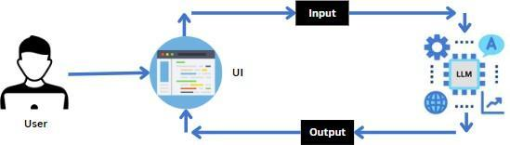

Project Flow:

- Users enter agricultural queries related to crop diseases, pests, fertilizers, crop management, or government schemes through the Streamlit interface. The query is sent to the backend where it is converted into vector embeddings using a Sentence Transformer model.
- The system performs semantic similarity search using a FAISS vector database containing agricultural question–answer pairs from Kisan Call Centre data to retrieve the most relevant solutions.
- The retrieved results provide quick offline guidance such as recommended pesticides, treatments, or crop management practices for the farmer’s query.
- For enhanced responses, the retrieved context is sent to the Llama 3.1 Instruct model through the OpenRouter API to generate a detailed AI-based explanation.
- Built with Python, Streamlit, FAISS, and Sentence Transformers, the platform provides fast retrieval, AI-generated insights, and an easy-to-use interface for agricultural assistance.

To accomplish this, we have to complete all the activities listed below,

- Model Initialization:
  - Store the OpenRouter API key using environment variables.
  - Initialize the Sentence Transformer embedding model and Llama 3.1 LLM.

- Application Development:
  - Build backend modules for query processing, embedding generation, and FAISS search.
  - Develop the Streamlit interface for user queries and result display.

- Deployment:
  - Deploy the application for online access.
  - Optimize performance for fast and reliable AI-based agricultural query responses.

Prior Knowledge:

You must have prior knowledge of the following topics to complete this project.

- LLM & Google Gemini API:

A large language model (LLM) is an advanced AI system that uses deep neural networks with billions of parameters to understand and generate human-like responses. In this project, the Gemini 2.0 Flash model by Google is integrated through the Generative AI API to analyze pet data, generate care advice, and perform image-based health assessments. Understanding how LLMs process natural language and images is essential. Examples of such models include ChatGPT by OpenAI, Claude by Anthropic, and Gemini byGoogle.
https://aistudio.google.com/api-keys

- Frontend Development (HTML, CSS, React):

Familiarity with building responsive and interactive web interfaces using HTML, CSS, and React (Vite). Understanding how to structure layouts, manage user inputs, and display AI-generated results effectively is required for creating an engaging user experience.

https://react.dev/
https://vitejs.dev/

- Flask Framework:

Knowledge of building backend web applications using Flask, a lightweight Python framework for developing RESTful APIs. Understanding how to create endpoints, handle JSON data, and connect AI models with APIs is crucial for enabling features like care tips generation, vet search, and image analysis.

https://flask.palletsprojects.com

- Google Generative AI Library:

Basic understanding of how to integrate and use the google-generativeai Python library for accessing Gemini’s text and vision models. This includes configuring API keys, sending prompts, handling responses, and managing model outputs securely.

https://pypi.org/project/google-generativeai/

Project Structure:
Create the Project folder which contains application file as shown below

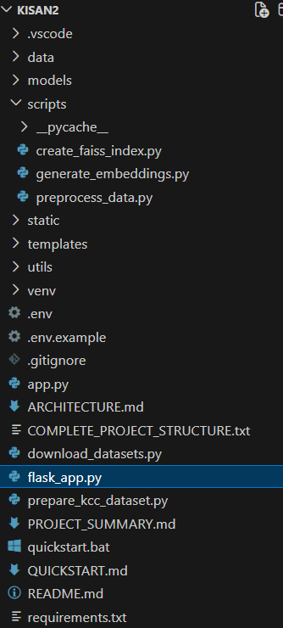

Milestone 1: Requirements Specification
Adding all the needed libraries in the requirements.txt file makes it easy to set up and run the project. It helps others install the same dependencies and avoid errors while working or deploying the project.

Activity 1: Create a requirements.txt file to list the required libraries.
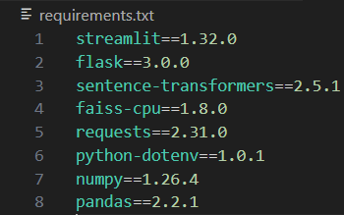

Activity 2: Install the required libraries.

Milestone 2: Initializing the Model

For initializing the model we need the Gemini API.

Activity 1: Generate Gemini API

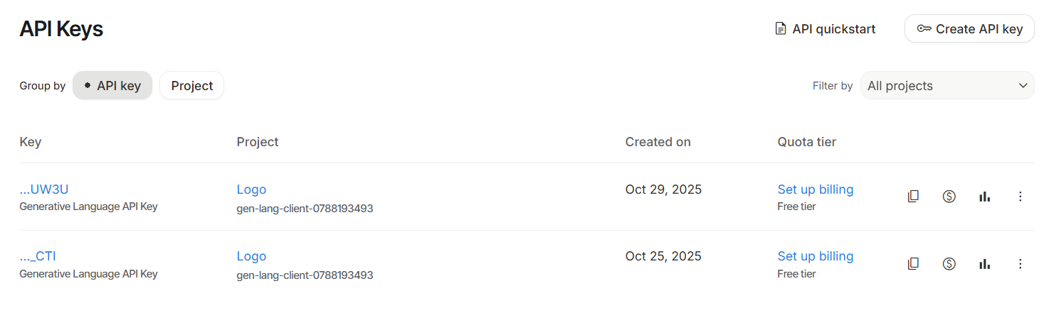

Click on the link
(https://developers.generativeai.google/)
- Then click on “Get API key in Google AI Studio”.
- Click on “Get API key” from the right navigation menu.
- Now click on “Create API key”. (Refer the above image)
- Copy the API key.

Activity 2: Initialize the pre-trained model

Activity 2.1: Import necessary files

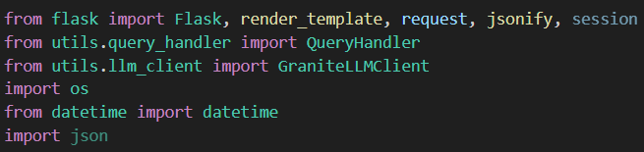

- Flask, render_template, request, jsonify, and session are imported to build the web application, handle user inputs, render HTML pages, return API responses, and manage user sessions.
- QueryHandler and GraniteLLMClient are custom modules used to process user queries, perform semantic search on stored data, and generate AI-based responses using the language model.
- os, datetime, and json are standard Python libraries used for accessing environment variables, handling date and time information, and reading or writing JSON data within the application.

Activity 2.2: Configuration of the Gemini API:
Configuring the API key:
The configure function is used to set up or configure the Gemini API with an API key. The provided API key, in this case, is " and it should be placed in “.env” file.

Activity 2.3: Define the model to be used:

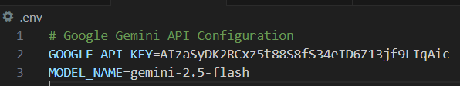

- Generation Settings:
Configured the Google Gemini API using the provided API key and initialized the Gemini 2.5 Flash model to generate AI-based responses. The model processes the given prompt through generate_content() and returns the generated text output for further use in the application.

Milestone 3: Interfacing with Pre-trained Model

In this milestone, we will build a prompt template to generate feedback based on the project details entered by the user.

Activity1: FAISS Index Creation
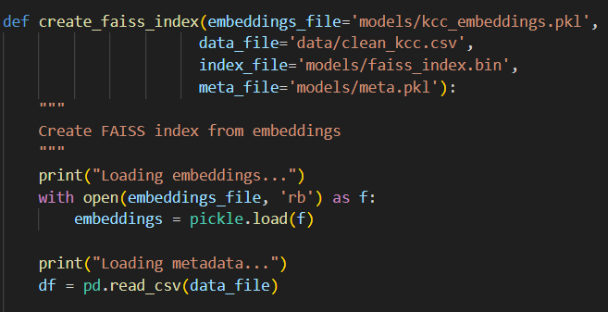

- Defines a function to create a FAISS index from stored embeddings.
- Loads embedding vectors from the kcc_embeddings.pkl file.
- Reads cleaned dataset metadata from clean_kcc.csv.
- Prepares data required to build and store the FAISS search index.

Embedding Generation for Agricultural Q&A:

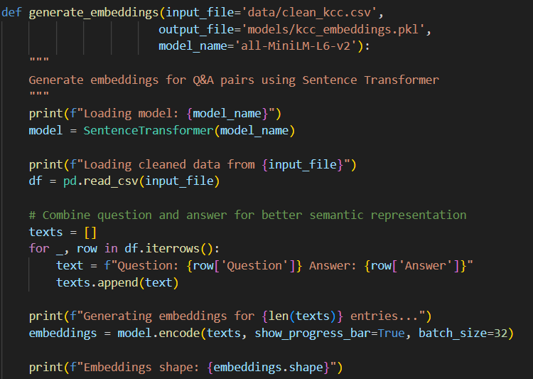

- Defines a function generate_embeddings() that loads the cleaned agricultural dataset and prepares text data for embedding generation using a Sentence Transformer model.
- Initializes the all-MiniLM-L6-v2 Sentence Transformer model, which converts textual data into dense vector embeddings for semantic similarity search.
- Combines each question and its corresponding answer into a single text representation to improve the semantic understanding of agricultural queries.
- Generates vector embeddings for all combined Q&A texts and stores them in a file (kcc_embeddings.pkl) for later use in FAISS-based similarity search.

KCC Data Preprocessing:
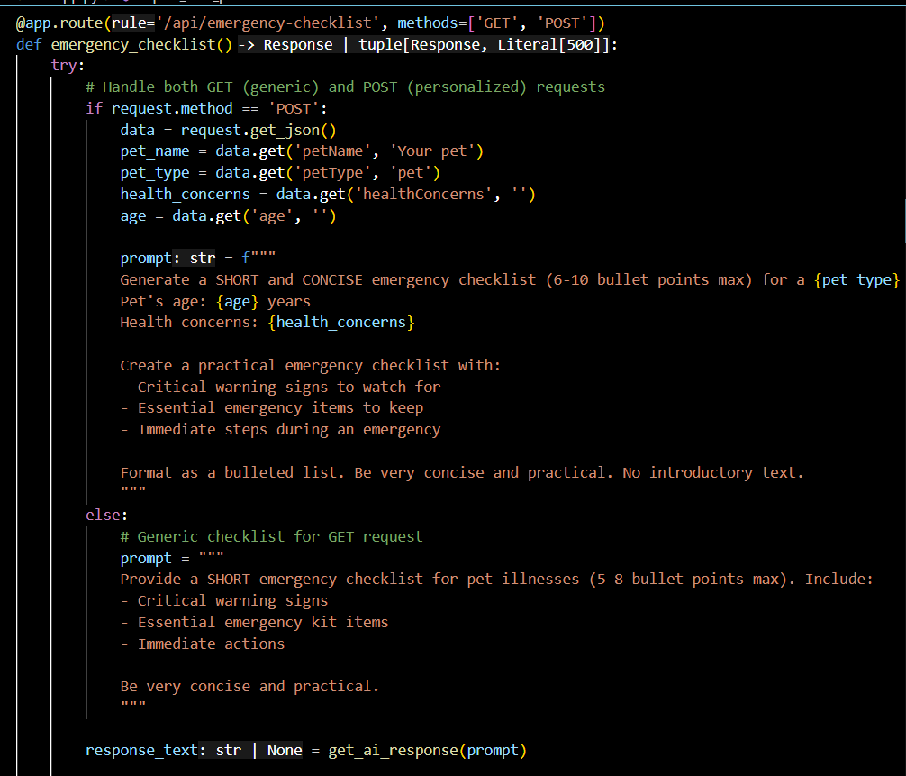
- Defines a function preprocess_kcc_data() to clean and standardize raw Kisan Call Centre question–answer data before further processing.
- Loads the agricultural dataset from questionsv4.csv, and if the file is not available, it automatically falls back to loading raw_kcc.csv.
- Uses Pandas to read the dataset with proper encoding and handles problematic rows using on_bad_lines='skip' to avoid processing errors.
- Prepares the cleaned dataset for further steps by organizing and saving the processed data into structured files such as clean_kcc.csv and kcc_qa_pairs.json.

Milestone 4: Model Deployment
In this milestone, the Kisan Call Centre Query Assistant is deployed using Flask to make the AI-powered agricultural support system accessible through a web-based interface. The application allows users to enter agricultural queries related to crop diseases, pest control, fertilizers, and government schemes directly in the browser. The backend processes the query using Sentence Transformer embeddings and FAISS similarity search to retrieve relevant solutions from the agricultural knowledge base. For enhanced responses, the system integrates a Large Language Model through the OpenRouter API, which generates detailed and context-aware explanations. Flask manages the backend APIs and ensures smooth communication between the user interface and the AI components, enabling fast, reliable, and real-time agricultural guidance for farmers and agricultural advisors.

Activity 1: Frontend Web Interface (HTML Template):
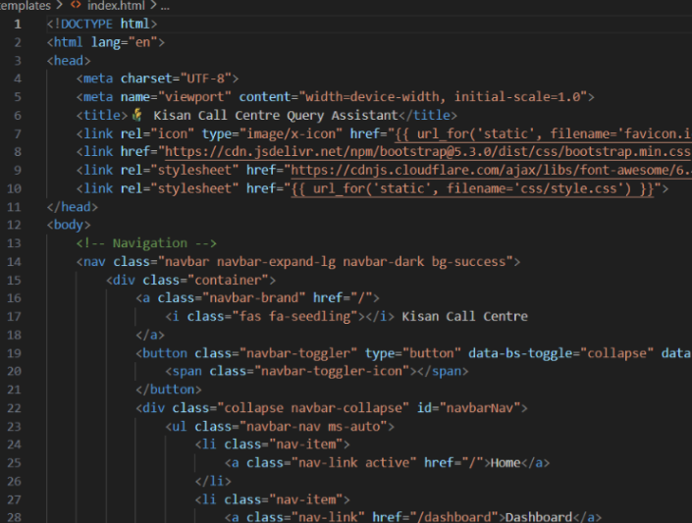

- Defines the main HTML structure for the Kisan Call Centre Query Assistant user interface.
- Includes Bootstrap and Font Awesome libraries for responsive design, styling, and icons.
- Uses Flask templating (url_for) to link static files like CSS styles and favicon.
- Creates a navigation bar with menu options such as Home and Dashboard for easy user navigation.

Activity 2: Dashboard Web Page:

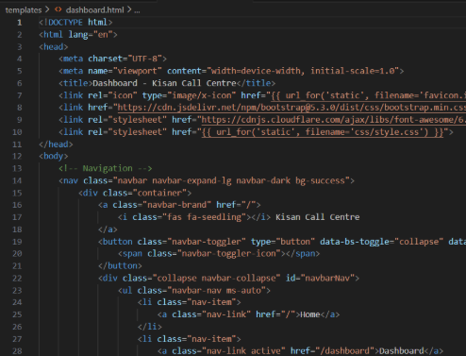

- Defines the HTML structure for the dashboard page used to display system features and results.
- Includes Bootstrap and Font Awesome libraries to provide responsive design and icons.
- Uses Flask template syntax (url_for) to load static resources like CSS and favicon.
- Implements a navigation bar with Home and Dashboard links for easy page navigation.

Activity 3: Run the web application
- Open the terminal from the vs code
- Navigate to the folder where your Python script is
- Now type “python flask_app.py” command
- Navigate to the deployment server where you can view flask is serving
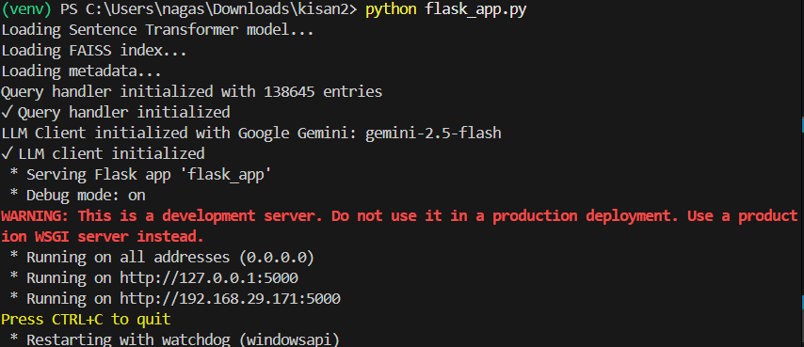

Activity 4: Output:
Now, the application will open in the web browser,
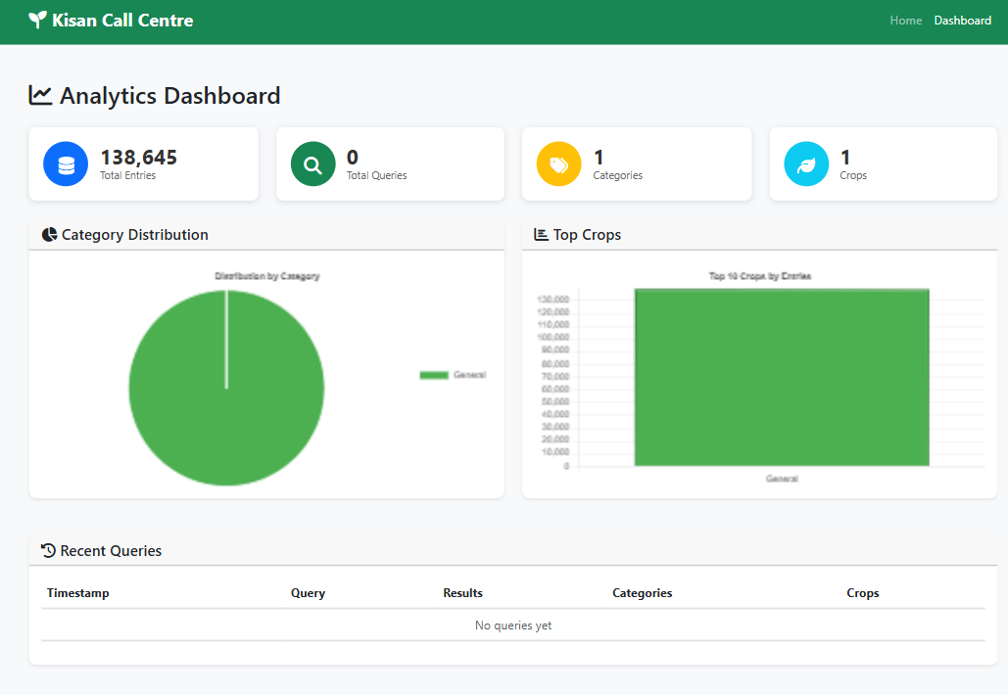
This is the output screen where functionalities are shown after giving input :
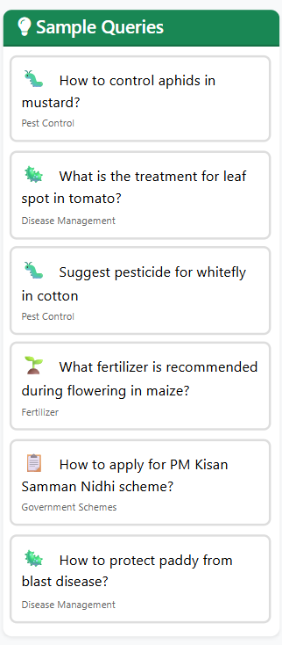

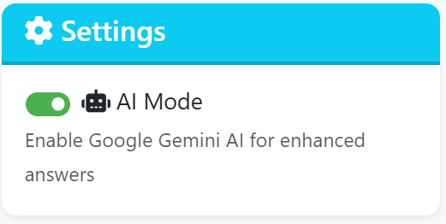

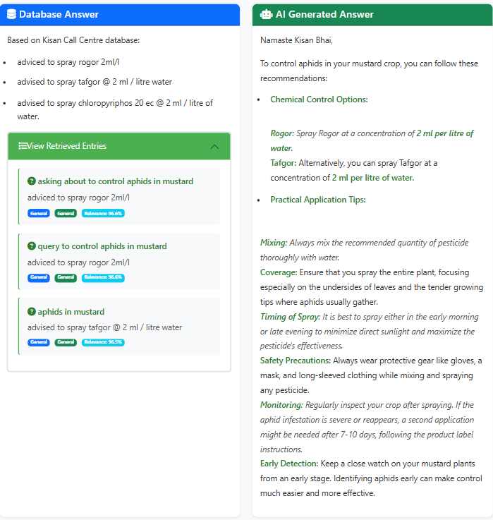

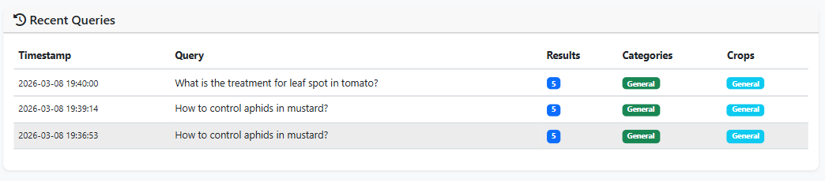

Conclusion:
The Kisan Call Centre Query Assistant is an AI-based system developed to provide quick and reliable solutions for agricultural queries. It uses semantic search and a language model to understand farmer questions and retrieve relevant information related to crop diseases, pest control, fertilizers, and government schemes through a simple web interface.
This project demonstrates how Artificial Intelligence can enhance access to agricultural knowledge. By delivering fast responses and intelligent recommendations, the system helps farmers make better decisions and supports more efficient and technology-driven farming practices.

